**PL/SQL SafeTransferFunds**

Scenario 1

1. Table Creation and Data Insertion

-- Create BankAccounts table:  
CREATE TABLE BankAccounts (  
 acc_id NUMBER PRIMARY KEY,  
 acc_holder VARCHAR2(100),  
 acc_balance NUMBER  
);

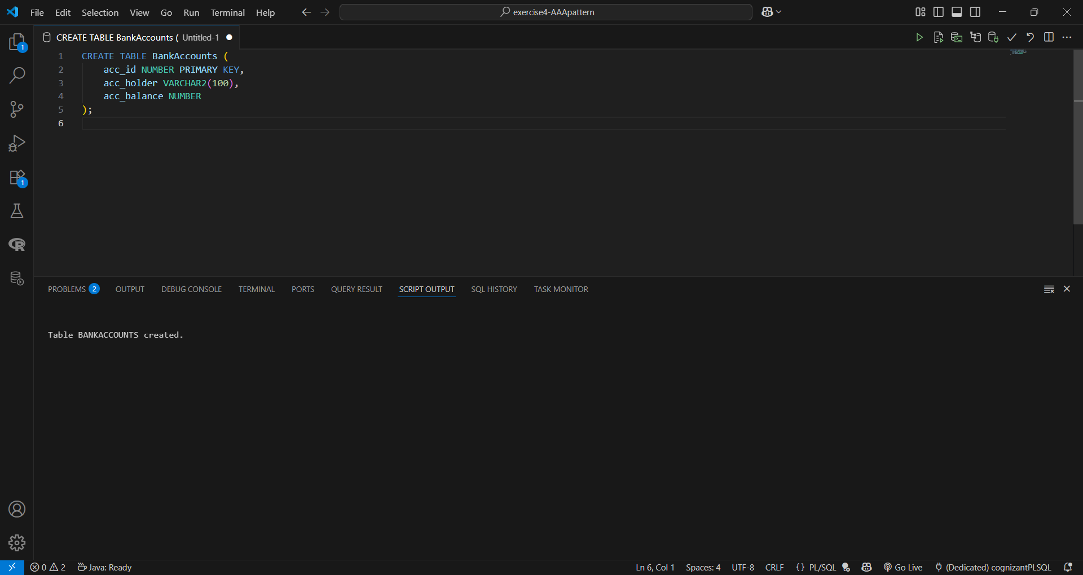  
  
-- Insert sample data  
INSERT INTO BankAccounts VALUES (201, 'Arjun', 3000);  
INSERT INTO BankAccounts VALUES (202, 'Bhavna', 1500);  
INSERT INTO BankAccounts VALUES (203, 'Charan', 400);  
  
COMMIT;

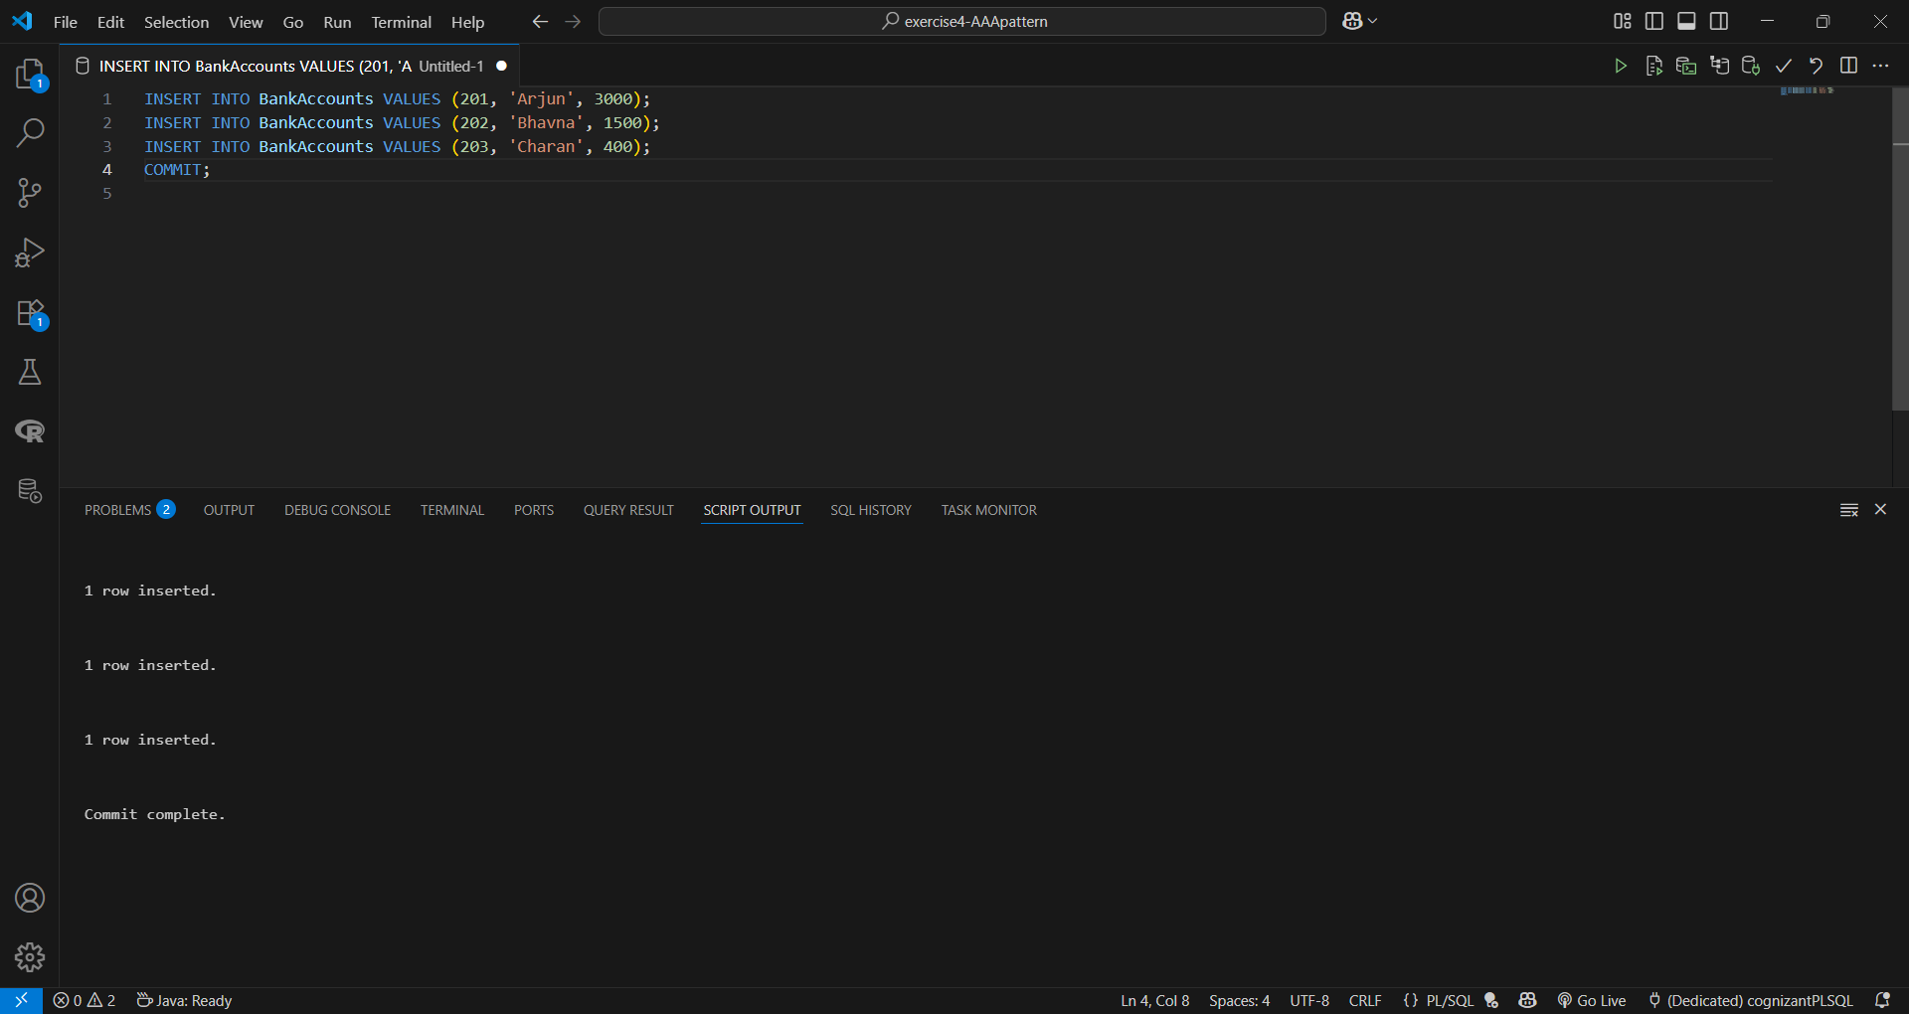

2. Procedure: PerformFundTransfer

CREATE OR REPLACE PROCEDURE PerformFundTransfer(  
 sender_id IN NUMBER,  
 receiver_id IN NUMBER,  
 transfer_amt IN NUMBER  
)  
IS  
 insufficient_balance EXCEPTION;  
 sender_balance NUMBER;  
BEGIN  
 SELECT acc_balance INTO sender_balance FROM BankAccounts WHERE acc_id = sender_id;  
  
 IF sender_balance < transfer_amt THEN  
 RAISE insufficient_balance;  
 END IF;  
  
 UPDATE BankAccounts SET acc_balance = acc_balance - transfer_amt WHERE acc_id = sender_id;  
 UPDATE BankAccounts SET acc_balance = acc_balance + transfer_amt WHERE acc_id = receiver_id;  
  
 COMMIT;  
  
EXCEPTION  
 WHEN insufficient_balance THEN  
 ROLLBACK;  
 DBMS_OUTPUT.PUT_LINE('Transfer failed: Insufficient balance in account ' || sender_id);  
  
 WHEN OTHERS THEN  
 ROLLBACK;  
 DBMS_OUTPUT.PUT_LINE('Transfer failed due to an unexpected error: ' || SQLERRM);  
END;  
/

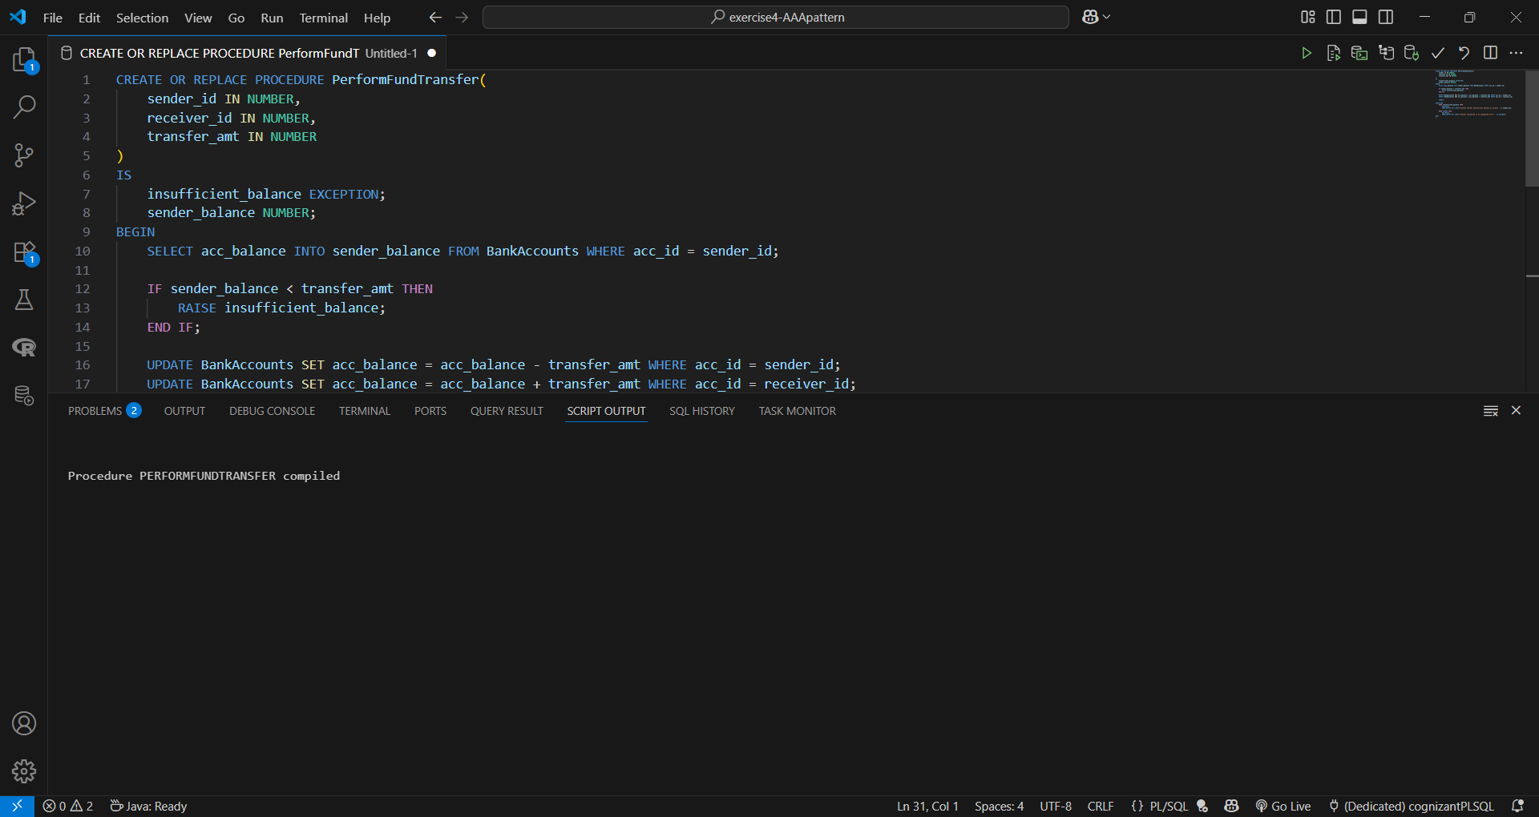

3. Test Block with Outputs

SET SERVEROUTPUT ON;  
BEGIN  
 DBMS_OUTPUT.PUT_LINE('--- Test 1: Valid Transfer ---');  
 PerformFundTransfer(201, 202, 1000); -- Success: Arjun to Bhavna  
 DBMS_OUTPUT.PUT_LINE('--------------------------------');  
  
 DBMS_OUTPUT.PUT_LINE('--- Test 2: Insufficient Balance ---');  
 PerformFundTransfer(203, 202, 1000); -- Fail: Charan doesn't have enough  
 DBMS_OUTPUT.PUT_LINE('--------------------------------');  
  
 DBMS_OUTPUT.PUT_LINE('--- Test 3: Invalid Sender ID ---');  
 PerformFundTransfer(999, 202, 100); -- Fail: Sender doesn't exist  
 DBMS_OUTPUT.PUT_LINE('--------------------------------');  
  
 DBMS_OUTPUT.PUT_LINE('--- Test 4: Invalid Receiver ID ---');  
 PerformFundTransfer(201, 999, 100); -- Fail: Receiver doesn't exist  
 DBMS_OUTPUT.PUT_LINE('--------------------------------');  
END;  
/

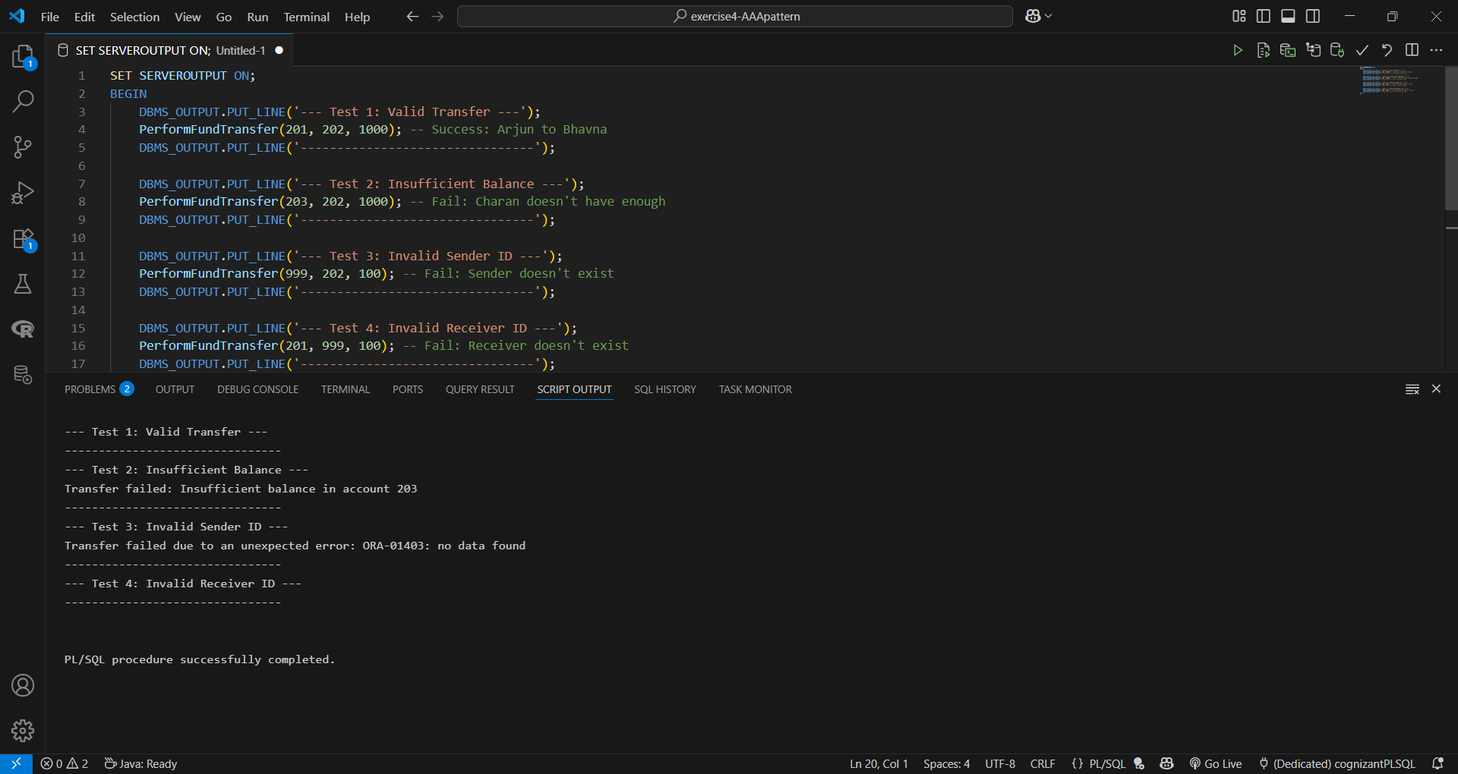

4. Verify Final Balances

SELECT * FROM BankAccounts ORDER BY acc_id;  
